5 December 2003

Henry Bush (c1173620)
ID: 98 90 90 6 1

MA 3D Computer Animation
Computer Animation Principles and Practise

“Is There a Place for Sequels in Cinema?”
Is There a Place for Sequels in Cinema?

The answer to this question is, of course, yes. They provide a huge amount of the income for film production companies in one of the most capital-led industries in the world. In fact, Paul Dergarabedian, president of Exhibitor Relations (a box-office tracking company) said recently “… if a sequel now grosses only two-thirds of its predecessor, it's considered a major failure” (2003, http://www.dealmemo.com/). But artistically speaking, should there be a place for them?

A considerable number of sequels are seen as surplus to audience requirements, and with very good reason: many such films simply attempt to copy the success of the original by staying as close to it as possible. This is a reliable source of income for the industry, but leaves us questioning whether all sequels are purely capital-driven ventures, intrinsically lacking the artistic vision that has forged the industry.

It is important to make clear at this point that discussion here will not include reference to films based on books, such as the recent Lord of the Rings (New Line Productions, 2001-2002) and Harry Potter (Warner Bros., 2001-2002) adaptations. These are based on books that existed before any of the films were conceived, and discussion of their merits would have to include scrutiny of the literary industry, as well as the problems involved when adapting a book to screen.

It is debatable whether the first example, Star Wars: The Empire Strikes Back (“ESB”, Lucasfilm, 1980), is a true sequel, given that the story of the entire six film set was reported to have been written at the same time as that of the original film (Star Wars: A New Hope (“ANH”, Twentieth Century Fox, 1977)). ESB fits into discussion here, however, as ANH was released as a completely self-contained film in order to gauge audience reaction before committing to a longer project. The fact that all six Star Wars films were written as a series no doubt helped ESB become one of the most successful, well received and critically acclaimed sequels of all time.

Though a coherent narrative is undoubtedly important, the most important factor in producing a creditable sequel is style. Style is what makes two films different, whether it is a difference in the cinematographic effects used, in the use of colour, or some other factor. In this case, ESB was much darker (emotionally speaking) than its predecessor was. ANH was filled with a sense of blind optimism, whilst ESB observes the rebellion constantly struggling to stay afloat. This change in style continued into the characterization: in ANH, the characters were portrayed as stereotypical heroes, clean-cut and fighting for justice at every turn. In ESB, the weaknesses and flaws in the heroes were exposed in such a way as to make them appear more human.

An example of a film with less well-respected sequels is Halloween (Compass International Pictures, 1978). The original film, directed by John Carpenter, was groundbreaking, a leading light in a now well-established film genre. It was one of the first films to take full advantage of techniques such as first-person camera work, and introduced the unnerving concept of the calm serial killer. There have been seven sequels to this film, the first being Halloween II (Universal Pictures, 1981) and the most recent being Halloween Resurrection (Dimension Films / Miramax Film Corp., 2002).

Halloween II, directed by Rick Rosenthal, followed on immediately from the first film, and was fairly well received. It had some changes in style (a higher body count, for example), and kept the story alive with new plot twists. Halloween Resurrection was also directed by Rosenthal, but lacks the appeal of the first sequel. The plot of even the original film was never particularly deep, but in Resurrection, the original story is almost completely overlooked. This need not be an issue, but the film does not succeed in establishing a serviceable situation or believable characters. This results in the audience lacking empathy with the characters, and as such a lack of compassion when the characters are threatened.

In Resurrection, the attempted changes of style are rare. Attempts to incite interest through modern technology fail, and comedy is introduced at a number of points. In most films, the introduction of a comedy can relieve tension and improve the dynamics of the plot. Films about serial killers, however, rely upon the build up of tension to breaking point: this is particularly true of the Halloween series. The release of this tension removes any empathy with the characters.

Perhaps the most critically acclaimed sequel of all time was Aliens (Twentieth Century Fox, 1986), the sequel to Alien (Twentieth Century Fox, 1979). The tag-lines of the two films explain the difference between them proficiently:
Alien: In space, no-one can hear you scream.
Aliens: This time it’s war.
The first film played on the feeling of isolation the crew of the Nostromo feel as, badly equipped and unprepared, they face an unknown enemy. In the second film, on the other hand, the characters know what they’re up against, and go in all guns blazing. The result is the comparison between a serial killer film and a war epic: the two types of films are completely different, and no one would ever dream of comparing one with the other.

In Alien the violence is mostly implied, whereas in Aliens it is shown in chilling detail (Figure 1). Both camera and characters move considerably more in Aliens, which instils a feeling of blind panic in the viewer; this compares with the frozen terror that the stalking nature of the creature in the first film imparts.

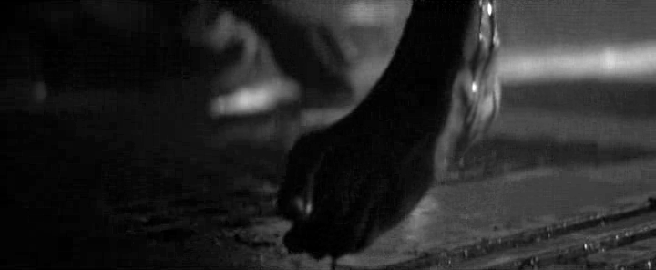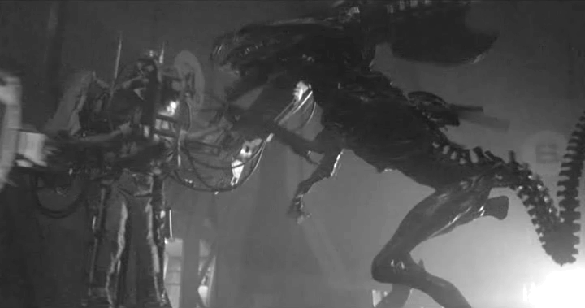
Figure 1: The implied slaughter in Alien (left) contrasts sharply with the explicit violence in Aliens (Stills: © Twentieth Century Fox)

Despite all the differences, some elements of the style must remain the same, in order that the film is seen as a sequel and not a completely different film. One example from both films is the use of dark scenes containing little colour in order to portray foreboding.

The following two sequels to Alien, Alien³ (Twentieth Century Fox, 1992) and Alien Resurrection (Twentieth Century Fox, 1997), were remarkably unsuccessful. Alien³ was intended as a return to the single creature realm of Alien. The film relied heavily on techniques that flourished in Alien, but were no longer appropriate: much of the tension in Alien was built up by fear of the unknown in the audience, but the audience know what the creature looks like and is capable of by the time they watch the third film. Here, the lack of a change in style resulted in a bland feeling to the film.

It is worthy of note that both of the examples described here of well executed sequels have different directors from the respective original films. This is clearly helpful in executing a change in style, but there are examples of well-respected sequels with the same director as the original film: one such example is The Godfather: Part II (Paramount, 1974; Part I: Paramount, 1972).

Style must change between a film and its sequel in order for it to be seen as new and interesting, otherwise it is likely to appear uninspiring. The reason for this is most likely that if a director is concentrating on retaining the feel of the original film, their focus is shifted away from creating a new and interesting work of art. The appendix contains a list of box-office figures, and powerfully illustrates the power of the sequel in modern cinema: for example, the first weekend box-office takings of Austin Powers – The Spy Who Shagged Me (New Line Productions, 1999) were greater than the total box-office takings of the original film, Austin Powers – International Man of Mystery (New Line Productions, 1997). There will always be a place for sequels in cinema, but if a director wishes to retain their artistic integrity, they should consider their reasons very carefully before undertaking the extraordinarily difficult task of producing a sequel that rivals the original film in artistic vision.

Appendix

Box Office Figures of Films and Their Sequels

All figures are in US$, and refer to US box office figures only. In the case of re-released films, the opening weekend figures refer only to the first release, but the gross figures include all releases.

Films discussed in this essay and their sequels:
Film | Year | Budget | Opening weekend | Most recent gross figures
Star Wars: Episode IV – A New Hope | 1977 | $11,000,000 | $1,554,475 | $460,935,665
Star Wars: Episode V – The Empire Strikes Back | 1980 | $18,000,000 | $6,415,804 | $290,158,751
Star Wars: Episode VI – Return of the Jedi | 1983 | $32,500,000 | $30,490,619 | $309,125,409
Star Wars Episode I – The Phantom Menace | 1999 | $115,000,000 | $64,810,970 | $431,065,444
Star Wars Episode II – Attack of the Clones | 2002 | $120,000,000 | $80,027,814 | $310,675,583
Halloween | 1978 | $325,000 | N/A | $47,000,000
Halloween II | 1981 | N/A | $7,446,000 | N/A
Halloween III: Season of the Witch | 1982 | $2,500,000 | N/A | $14,400,000
Halloween 4: The Return of Michael Myers | 1988 | $5,000,000 | $6,831,000 | $17,768,757
Halloween 5 | 1989 | $5,000,000 | $6,332,000 | $11,642,254
Halloween: The Curse of Michael Myers | 1995 | $5,000,000 | $8,581,000 | $15,116,634
Halloween H20: 20 Years Later | 1998 | $17,000,000 | $16,187,724 | $55,004,135
Halloween Resurrection | 2002 | $15,000,000 | $12,292,121 | $30,259,652
Alien | 1979 | $11,000,000 | $1,023,665 | $78,900,000
Aliens | 1986 | $18,500,000 | $10,052,042 | $81,843,800
Alien³ | 1992 | $50,000,000 | N/A | $55,473,600
Alien Resurrection | 1997 | $70,000,000 | $25,789,455 | $47,748,610
Other films:

Spy Kids | 2001 | $35,000,000 | $26,546,881 | $112,692,062
Spy Kids 2: Island of Lost Dreams | 2002 | $39,000,000 | $16,711,716 | $85,570,368
Spy Kids 3-D: Game Over | 2003 | $39,000,000 | $33,417,739 | $111,035,662
Austin Powers – International Man of Mystery | 1997 | $17,000,000 | $9,548,111 | $53,868,030
Austin Powers – The Spy Who Shagged Me | 1999 | $33,000,000 | $54,917,604 | $205,399,422
Austin Powers in Goldmember | 2002 | $63,000,000 | $73,071,188 | $213,079,163
Scary Movie | 2000 | $19,000,000 | $42,346,669 | $156,997,084
Scary Movie 2 | 2001 | $45,000,000 | $20,503,356 | $71,277,420
Scary Movie 3 | 2003 | $45,000,000 | $48,113,770 | N/A

Bibliography

DERGARABEDIAN, P., 2002, “Hollywood 2002, Big Sequels, Big Money”, IMECOM (Entertainment, Media & Communications Information Services).
Accessible from http://www.dealmemo.com/Content/Jan2002/Hollywood_2002.htm (accessed 26 November 2003)

Information in appendix courtesy of The Internet Movie Database (http://www.imdb.com). Used with permission.

